Previous Solution 1: Ballchasing.com
Ballchasing.com is a website providing a public database for players to upload their replays to so that they, as well as others, can view and analyse them. The key part that will be relevant to my project will be its detailed visualization of statistics, which will prove useful in my Data Overview section.

1.1 Filtering data by category
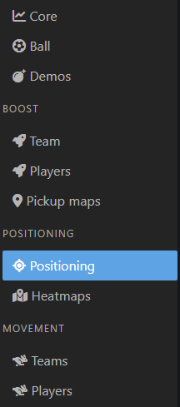
This is a useful way to prevent the user from becoming overwhelmed by the numerous statistics that the website provides.

1.2 Using Bar charts to visualise data
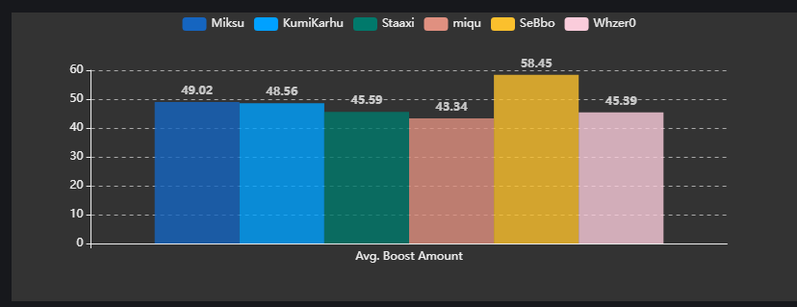
Almost all of the data is visualised and compared via the use of bar charts, this type of chart provides simple and effective comparison between the players.
The clear legend and contrasting colours help separate the data by the players, making comparison even more intuitive.

Previous Solution 2: Rocket League Tracker (rocketleague.tracker.network)
The main purpose of this website is to store users’ current and previous ranks so other players can view them as well as to compare their own to previous seasons. It displays overall trend in rank and provides basic statistics across all games.
2.1 Stacked Bar Chart (Goal to Assist to Save ratio) (Play Style)
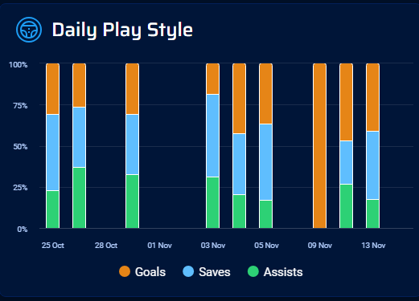
This website names the ratio between goals, saves, and assists the user’s playstyle, which although can be partially indicative of how a user plays, this varies far too much game by game, and even viewing the overall pie chart does not tell you much about the user’s actual play style.
However, a useful takeaway from this would be the use of stacked bar charts to display ratios across different days, which in my case may be useful to compare ratios of certain statistics between games lost and games won.
The contrasting colours are also useful to easily see the separation in the data, which is consistent across the other charts provided on this website.
2.2 Loading indicator
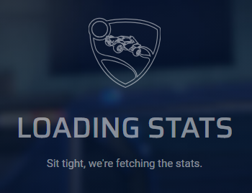
Since the website is required to fetch many statistics and visualise them, this can take a few seconds, and to make it clear the website is working, it uses this loading indicator to ensure the user that progress is being made. This will be useful in my project since I plan to allow a high maximum replay limit, which could take time to parse through and generate the charts for, so it would be useful for the sake of clarity to the user to provide an indication that progress is being made; if possible, I could extend this by somehow showing the user which replay the site is currently parsing, so the user has somewhat of an understand how long they will need to wait.
2.3 Flaws in this website’s representation of playstyle
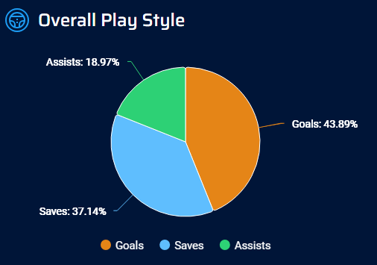
Like mentioned in 2.1, the ratio between these 3 simple and shallow statistics does not provide much detail as to how a user actually plays, and what they could do to improve, especially since most users will have very similar charts to this.
Additionally, the use of all data across the entire user’s career does not provide an accurate representation of the user’s current playstyle, since a player will always end up playing differently as they improve. This means that a user’s playstyle from when they had just started the game is affecting what the website is showing them, making it almost useless to learn anything useful from at their current level, given they’ve improved/changed.
Another flaw to using data from so long ago is that players in general have changed and improved in each rank over time, this means that an average Diamond ranked player from 5 years ago is much different to the average Diamond ranked player today, which although not relevant to the pie chart, will be relevant when using training data in my project and should be considered.
To improve this, I will use a much wider set of statistics to indicate playstyle, as well as make it clearer what those statistics show about them. I will also use RECENT training data to ensure that the model is not skewed by outdated data.

